# Vikas Tiwari

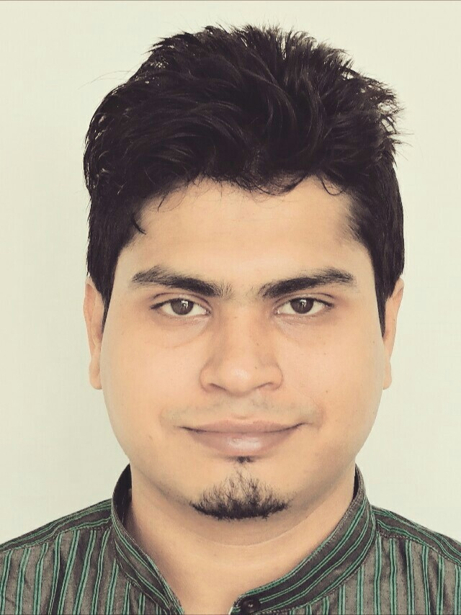

Industry expertise

* Cards

Core competences

* Functional testing
* Manual Testing
* Agile Testing
* Regression testing
* Validation testing

Education

* B.E(Electronics and Communication)

Junior Test Engineer

The information in the CV is highly confidential and can be used only in the purpose it was requested for. It is not allowed to forward CV for any other purposes!

|  |
| --- |
| **Summary**  A bright, talented, ambitious and self-motivated test engineer with a strong technical background who possesses self-discipline and the ability to work with the minimum of supervision. Having a proven ability to carry out the creation of test cases, appropriate implementation of individual tests, log outcomes and communicate the results to work colleagues and clients. Possessing excellent documentation communication skills alongside an ability to formulate, advice and implement testing strategy. Using initiative to develop effective solutions to problems with an active and dynamic approach to work and getting things done efficiently.  **Latest experiencE**  Test engineer  Employer: Vikas Tiwari  Duration: 2016-06- till now  Working as Test Engineer in Banking & Finance at Tieto IT Services India Pvt Ltd. My Current Role: Test Engineer.1 Customer business understanding Intercultural and communication skills Software engineering process  Software quality  Strategic thinking  Technology and product knowledge Test engineering  Test management Test tools and frameworks  Testing principles and concepts  Testing type specific competences |

**PROJECT SUMMARIES**

|  |  |
| --- | --- |
|  | |
|  | SABB Customizations 2017-12 - till now | THE SAUDI BRITISH BANK  ***Test engineer***  Worked on EntraCard Product which is a modern card management application system used by some leading banks across the globe for managing their card business.  Responsibilities:   * Prepared and Executed Test cases as per System Requirements * Involved in GUI, Functional, Regression testing and System Testing Involved in all testing related documentation. Involved in Bugs Tracking & Prepare Bug Report Document. * Involved in weekly review meetings. * API Testing   Competencies used: Agile Testing, Functional testing, Manual Testing, Regression testing |
|  | DIGITAL PAYMENTS SERVICES 2017-01 - till now | STANDARD CHARTERED BANK  ***Test engineer***  Digital Payment Services’ is used to Perform Cardless Transactions Using Samsung Pay or Apple Pay Wallet Service Providers in Credit Card banking domain.  Responsibilities:   * Understanding the Requirements and Functional Specifications of the application. * Participated in identifying the Test scenarios and designing the Test cases. * Prepared and Executed Test cases as per System Requirements * Involved in GUI, Functional, Regression testing and System testing * Involved in all testing related documentation. * Involved in Bugs Tracking & Prepare Bug Report Document. * Involved in weekly review meetings.   Competencies used: Agile Testing, Functional testing, Manual Testing, Regression testing |
|  | Marginalen Bank - Entracard Product 2016-06 - till now | MARGINALEN BANK  ***Test Enginner***  Worked on EntraCard Product which is a modern card management application system used by some leading banks across the globe for managing their card business.  Responsibilities:   * Prepared and Executed Test cases as per System Requirements * Involved in GUI, Functional, Regression testing and System testing * Involved in all testing related documentation. * Involved in Bugs Tracking & Prepare Bug Report Document. * Involved in weekly review meetings.   Competencies used: Agile Testing, Functional testing, Manual Testing, Regression testing  **Professional Summary**   * Total **1.10** years of experience in Software testing i.e. Manual Testing * Expertise in **SDLC** and **STLC** concepts. * Well versed with **Bug Life Cycle**. * Experienced in **Manual Testing** includes **GUI**, **Functional**, **Regression** and **System** Testing. * Good knowledge on **Banking, Credit Card, Financial services**. * Good Exposure on **QTP.** * Well versed with **Window-based** Software’s. * Strong knowledge on **SQL** for **DB** related tests. * Good Exposure on **QC.** * Experience in preparing Weekly status reports and Daily status reports. * Ability to work under dead lines, worked as an active team member and willingness to accept responsibilities * Good in communication, coordinate with team and skill improvement  |  |  |  |  | | --- | --- | --- | --- | |  | **SCHOOL/COLLEGE** | **YEAR OF PASSING** | **PERCENTAGE** | | **B. E** | TIT EXCELLENCE/RGPV BHOPAL | 2015 | 66.70% | | **12th** | VATSALYA SR. SEC. SCHOOL, SAGAR (M.P) | 2010 | 64.40% | | **10th** | VATSALYA SR. SEC. SCHOOL, SAGAR (M.P) | 2008 | 84.40% |   **FORMAL EDUCATION** |

**Courses & Trainings**

* Tieto certified Scrum training program, 2016-07

**Certifications**

* MINDSCRIPTS PUNE, 2015-09  
  IBM CE CERTIFIED
* MINDSCRIPTS PUNE, 2015-09  
  Diploma In Java

**Areas of Expertise**

General, Communication

|  |  |  |  |  |  |
| --- | --- | --- | --- | --- | --- |
|  | Presentation skills |  |  |  |  |

General, Soft skills

|  |  |  |  |  |  |
| --- | --- | --- | --- | --- | --- |
|  | Emotional Intelligence |  |  |  |  |

Industry, Financial Services

|  |  |  |  |  |  |
| --- | --- | --- | --- | --- | --- |
|  | Banking and Cards |  |  |  |  |

SW Development, Testing

|  |  |  |  |  |  |
| --- | --- | --- | --- | --- | --- |
|  | Agile Testing |  | Validation testing |  | Defect Tracking |
|  | Functional testing |  | Integration testing |  | Manual Testing |
|  | Performance Testing |  | Regression testing |  | Test execution, status reporting and analysis |
|  | Testing process |  |  |  |  |

Technologies & Platforms, Java

|  |  |  |  |  |  |
| --- | --- | --- | --- | --- | --- |
|  | J2SE – Core Java |  |  |  |  |

Technologies & Platforms, Operating systems

|  |  |  |  |  |  |
| --- | --- | --- | --- | --- | --- |
|  | Windows 10, QC, JIRA, TN3270, MasterCard Simulators , VISA Switches |  |  |  |  |

**Language skills**

|  |  |
| --- | --- |
| Hindi | ■■■■■ |
| English | ■■■■■ |

**Contact person**

|  |  |
| --- | --- |
| Full name | Vikas Tiwari |
| E-mail | Vikastiwari9921@gmail.com |
| Work telefax | 9284427534 |